**Needle In a Haystack**

***Misc***

**Challenge:**

I lost my flag and I can't seem to find it. I know I put it in this folder, but it is not showing up.

Can you help me find it?

Attached - haystack.zip

**Approach:**

Not much to do here, we just use the command:

strings * | grep “NICC{“

and we got the flag:

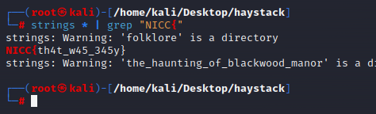

(Actually if you’ll notice, you’ll see a file named flag.txt.txt which had the flag lol, no need for commands and stuff)

**Flag: NICC{th4t_w45_345y}**

Congrats!!

Happy Hacking!